Getting started with elevation data

SRTM Digital Elevation Data 30m

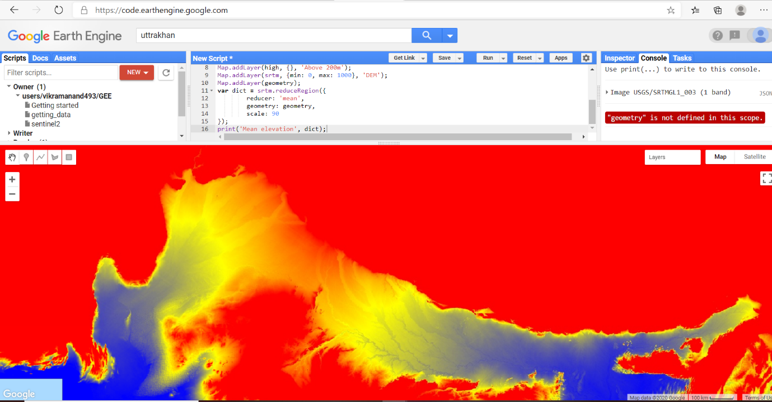

## Hillshading and slope

## C:\Users\vikra\AppData\Local\Packages\Microsoft.Office.Desktop_8wekyb3d8bbwe\AC\INetCache\Content.Word\HILLSHADE.PNG

## Applying a computation to an image

## C:\Users\vikra\AppData\Local\Packages\Microsoft.Office.Desktop_8wekyb3d8bbwe\AC\INetCache\Content.Word\ABOVE 200M.PNG